Charles Silkin

27 October 2023

**Performance of Pass Rushers Over Time**

**\*NOTE: Raw data has been modified due to database being private\***

**Introduction:**

In this report, I present my findings regarding the ability of pass rushers to sustain their production over the course of an opponent’s offensive drive. For this analysis, I specifically focused on four NFL pass rushers for the 2023 season only **(denoted as EDGE 1, EDGE 2, EDGE 3, and EDGE 4)**.

In order to obtain the data, I used the TruMedia website to consolidate a database of the run and pass plays in which each of the four pass rushers are on the field. I then downloaded the custom report as a .csv file and worked with that file in R.

**Statistical Procedures Used:**

The statistic I used to determine production for pass rushers was pressure rate, which in this case is the total number of pressures generated by the pass rusher divided by the number of opposing QB dropbacks. I used pressure rate instead of sack rate because pressures are the most sustainable form of production in terms of how good the pass rusher is at getting to the opposing QB over the course of any measurement of time.

My first step was getting the number of the snap (i.e. a player’s first snap, second snap) with respect to players’ season total, game total, and drive total. I grouped the data by player, game, and drive number, then used a row counter method which indexes the data based on the grouping.

Next, I created a function to get a players’ cumulative pressure rate. Instead of measuring pressure rate at a certain dropback or snap number, a cumulative pressure rate is a statistic which, at snap number $n$, adds the total number of pressures gained in the previous $n-1$ snaps to an indicator variable of either 1 or 0 at the current snap, and divides that total by the current snap number $n$.

This table below denotes an example of how cumulative pressure rate is calculated.

|  |  |  |  |  |  |  |
| --- | --- | --- | --- | --- | --- | --- |
| **Pressure (1 if yes, 0 if no)** | 0 | 1 | 1 | 0 | 0 | 0 |
| **QB Dropback Number** | 1 | 2 | 3 | 4 | 5 | 6 |
| **Cumulative Pressure Rate** | $$\frac{0}{1}=0\%$$ | $$\frac{1}{2}=50\%$$ | $$\frac{2}{3}=66\%$$ | $$\frac{2}{4}=50\%$$ | $$\frac{2}{5}=40\%$$ | $$\frac{2}{6}=33\%$$ |

I used a cumulative pressure rate instead of averaging the pressure rate at each certain snap number in the drive is because cumulative pressure rate takes into account how productive the pass rusher was on previous snaps, which better answers the question on if pass rushers sustain their production over the course of a drive.

To get the cumulative pressure rate at each snap in the drive, I grouped the data by dropback number (first pass rush snap of the drive, second pass rush snap of the drive, etc.), then computed the average cumulative pressure rate at each snap number.

**Summary of Statistical Findings:**

Based on the cumulative pressure rates of the four EDGE rushers over the course of their snap counts on individual drives, I found that their combined production over the course of a drive does indeed diminish. On the first pass rush snap of the drive, the average pressure rate of those four pass rushers is approximately 15.6%. From there, there is a sharp decrease in the cumulative pressure rate from the first pass rushing snap to the second, with some fluctuations from there.

This table denotes the number of plays at each pass rush snap number and the associated cumulative pressure rate.

|  |  |  |
| --- | --- | --- |
| **Pass Rush Snap Number** | **Number of Snaps** | **Cumulative Pressure Rate** |
| 1 | 243 | 15.64% |
| 2 | 185 | 8.38% |
| 3 | 130 | 5.9% |
| 4 | 77 | 6.17% |
| 5 | 49 | 4.49% |
| 6 | 33 | 2.53% |
| 7 | 24 | 3% |
| 8 | 13 | 3.84% |
| 9 | 8 | 2.78% |
| 10 | 4 | 5% |
| 11 | 1 | 0% |
| 12 | 1 | 0% |

The decreasing number of snaps at each snap number can be explained by the fact that there are a number drives with only one play where one of the pass rushers is rushing the passer, some where there are two pass rush plays, and there was even one drive where a pass rusher was rushing the QB 12 times.

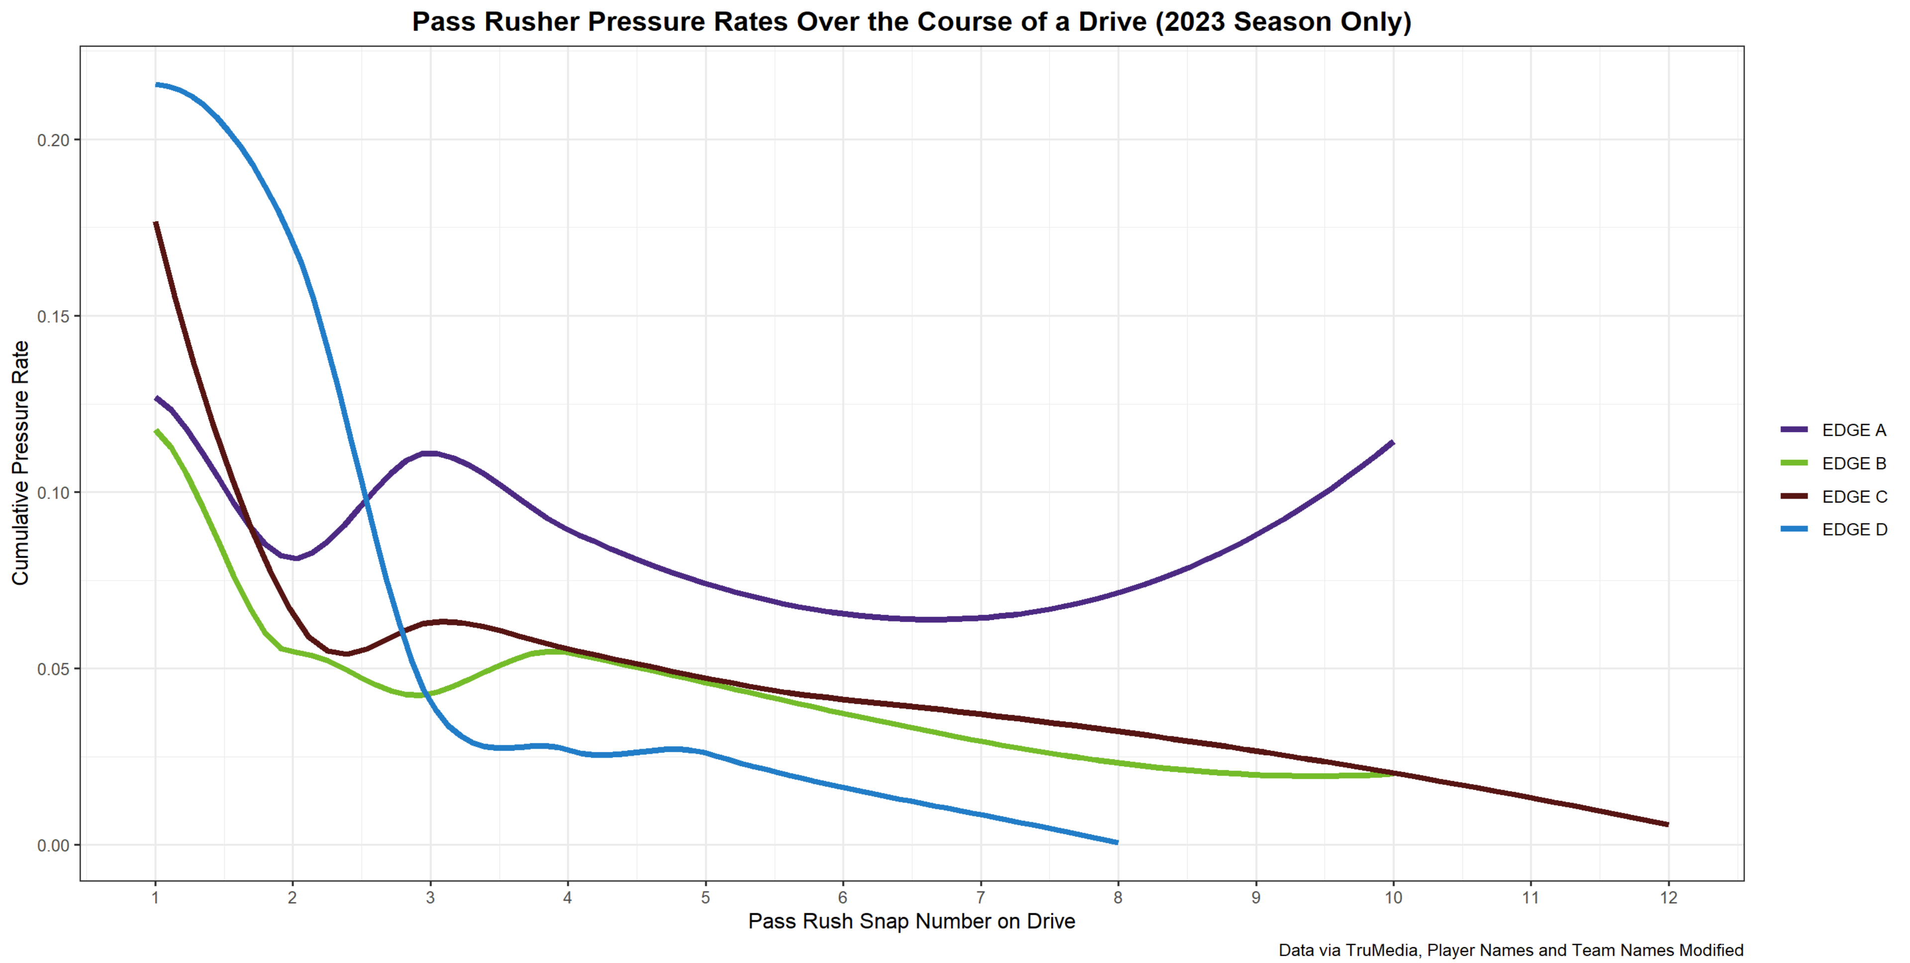I also created a smooth line graph using the ggplot package in R to chart the average cumulative pressure rate of each individual pass rusher separately:

As seen in the graph, the cumulative pressure rate decreases for each pass rusher, however, each pass rusher has varying levels of consistency in terms of how steep their drop-offs are. **EDGE D** is the most interesting case to me, as he leads this group with an astounding pressure rate of 21.56% on average on his first pass-rushing snap, but his production decreases the most on a snap-to-snap basis, with a 17% average pressure rate across his first two snaps, all the way down to 4.04% by his third pass-rush snap of the drive. **EDGE A** is the most consistent of this group, with his cumulative average dipping a bit around his 7th snap but maintaining a consistent average pressure rate across his drives. **EDGE B** and **EDGE C** have a similar pattern, with a big decrease from snap #1 to snap #2, a slight increase around their 3rd or 4th snap before experiencing a smooth drop-off.

**Other Interesting Notes:**

I was surprised to see the slight increase in cumulative pressure rate from snap #2 to snaps #3 to 4, but my hypothesis as to why that happens comes to what down it. I found that on average, the average time to throw for QB’s is significantly higher on 3rd and 4th downs compared to early downs (1st and 2nd down), per TruMedia.

|  |  |
| --- | --- |
| **Down** | **QB Time to Throw** |
| 1st down | 2.76 seconds |
| 2nd down | 2.66 seconds |
| 3rd down | 2.90 seconds |
| 4th down | 2.98 seconds |

This makes sense because on 3rd and 4th down, an offense is going to try and push the ball down the field in order to get a first down, rather than rely on a quicker passing game where the opposing CB’s can wrap up and tackle the receivers before they can get a chance to reach the first down marker. If a QB has more time to throw, they are spending more time in the pocket; as a result, the probability of a pass rusher getting pressure is also higher than if a QB spent less time in the pocket. It would be an interesting in a future study to further break down the data by down and see if the increase in cumulative pressure rate on the third and fourth pass-rushing snaps (depending on the pass rusher) is a result of most of those snaps being on later passing downs rather than early rushing downs.